VerdaSense — G4 Multimodal Experiment

Clinical Image Review Form

Reviewer: Ms Saw Shier Khee, Surgical Collaborator
Student: Tee Qi Jing (23004894)
Project: VerdaSense RAG — FYP2, Universiti Malaya
Date: _____________________________ 2026

Purpose of This Form
VerdaSense FYP2 is extending the wound dressing RAG system to accept actual wound photographs as additional input. A Vision AI model (VLLM) generates a clinical description from each image, which is then used to enrich the dressing recommendation.
This form asks you to review 8 wound images (one per wound type, WT01–WT08) and provide:
1. Image suitability — is this a clinically reasonable example of the wound type?
2. AI caption accuracy — is the VLLM's clinical description accurate?
3. Your clinical recommendation — what you would recommend for this wound.
Your responses will become the GOLD STANDARD for the G4 multimodal evaluation. Yellow-shaded cells are for you to fill in. No cell is mandatory — any input is valuable.

Colour Legend: Blue header = wound info (read only) Yellow cell = please fill in Grey cell = reference / system output (read only)

WT01 — Type 1 — Clean Granulating, Dry, Not Infected
✓ No antibiotic · No referral required
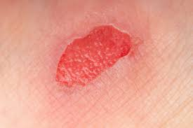  WT01_wound.jpeg | T.I.M.E. Wound Profile  T (Tissue): 100% Granulation  I (Infection): Not infected  M (Moisture): Low to moderate exudate  E (Edge): Advancing  Linked test cases: cat_a_type1_dry · cat_b_silver_clean_granulating · cat_b_skin_tear_fragile · cat_b_postop_clean · cat_b_burns_hand · cat_b_skin_tear_type2_flap · cat_b_burns_minor_epidermal · cat_c_film_vs_hydrocolloid

Field | Content / Response
AI Vision Caption  (VLLM output  — read only) | TISSUE: Approximately 90% healthy red granulation tissue fills the wound bed, with 10% pale pink epithelial tissue advancing from the edges.  INFECTION: No visible infection signs.  MOISTURE: The wound bed appears moist without excessive exudate. Periwound skin is dry, showing no maceration.  EDGE: Wound edges exhibit slight epibole, with some epithelialization noted. Edges are generally well-defined but show minor undermining.  ADDITIONAL: The wound measures approximately 1 cm × 1 cm, shallow depth. Periwound skin displays mild erythema, likely due to inflammation rather than infection.
1. Image Suitability  (Does this image  represent this  wound type?) | ☐ Suitable — image is a reasonable example ☐ Not suitable — image is misleading / incorrect  Comments / Corrections:
2. AI Caption  Accuracy  (Is the VLLM  description  clinically correct?) | ☐ Accurate — VLLM description is clinically sound ☐ Partially accurate — some errors (note below) ☐ Inaccurate — description is misleading  Comments / Corrections:
3. Caption  Corrections  (What did the AI  miss or get wrong?) | e.g. 'Infection signs visible but VLLM missed them' or 'Tissue % estimate is off'
4. Your Clinical  Description  (What do you see  in this image?) | Describe tissue, infection signs, exudate, wound edges — as you would document it clinically
5. Primary Dressing  Recommendation  (Based on image +  wound type) | e.g. 'Silver dressing, change every 2–3 days' or 'Hydrogel + secondary foam'
6. Secondary  Dressing  (If applicable) | e.g. 'Foam as secondary' or 'Not required'
7. Debridement  Required? | ☐ Not required ☐ Autolytic (dressing-based) ☐ Bedside deslough ☐ Surgical / OT debridement  Comments / Corrections:
8. Antibiotic  Recommendation | ☐ Antibiotic NOT indicated ☐ Topical antimicrobial dressing only (no systemic ABx) ☐ Systemic antibiotic recommended  Comments / Corrections:
9. Referral /  Escalation | ☐ No referral — manageable in community ☐ Referral recommended to GP / clinic ☐ Urgent specialist referral required  Comments / Corrections:
10. Additional  Clinical Notes  (Anything else?) | Any safety concerns, contraindications, Malaysian-specific considerations, etc.
VerdaSense  System Output  (for comparison  — read only) | Recommendation: Primary: Film dressing (Alt: Thin hydrocolloid) — change every 2–5 days  Contraindicated: Silver dressings · Charcoal dressings
Prior Panel  Comments  (from Cat A  review — read only) | Panel 1: Agreed | Panel 2: Agreed | Panel 3: Agreed

WT02 — Type 2 — Granulating, High Exudate, Not Infected
✓ No antibiotic · No referral required
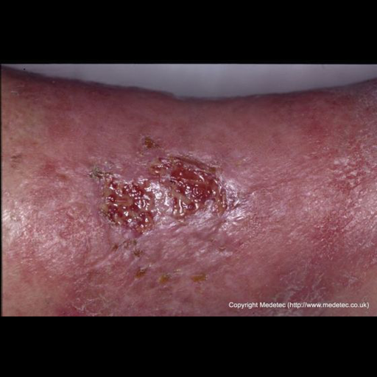  WT02_medetec_0116.png | T.I.M.E. Wound Profile  T (Tissue): 90–95% Granulation, 5–10% NV (slough)  I (Infection): Not infected  M (Moisture): High exudate  E (Edge): Advancing  Linked test cases: cat_a_type2_wet · cat_c_dressing_saturation · cat_c_heavy_exudate_maceration · cat_d_notes_malodour_clean

Field | Content / Response
AI Vision Caption  (VLLM output  — read only) | TISSUE: Approximately 60% healthy red granulation tissue, 30% yellow fibrinous slough, 10% pale avascular tissue.  INFECTION: No visible infection signs.  MOISTURE: Moderate exudate; wound bed appears moist with serous fluid. Periwound skin is slightly macerated.  EDGE: Wound edges show epibole with some undermining noted. Epithelialization is minimal, edges appear non-advancing.  ADDITIONAL: Estimated wound size approximately 2 cm × 2 cm. Depth appears superficial. Periwound skin exhibits mild erythema and dryness.
1. Image Suitability  (Does this image  represent this  wound type?) | ☐ Suitable — image is a reasonable example ☐ Not suitable — image is misleading / incorrect  Comments / Corrections:
2. AI Caption  Accuracy  (Is the VLLM  description  clinically correct?) | ☐ Accurate — VLLM description is clinically sound ☐ Partially accurate — some errors (note below) ☐ Inaccurate — description is misleading  Comments / Corrections:
3. Caption  Corrections  (What did the AI  miss or get wrong?) | e.g. 'Infection signs visible but VLLM missed them' or 'Tissue % estimate is off'
4. Your Clinical  Description  (What do you see  in this image?) | Describe tissue, infection signs, exudate, wound edges — as you would document it clinically
5. Primary Dressing  Recommendation  (Based on image +  wound type) | e.g. 'Silver dressing, change every 2–3 days' or 'Hydrogel + secondary foam'
6. Secondary  Dressing  (If applicable) | e.g. 'Foam as secondary' or 'Not required'
7. Debridement  Required? | ☐ Not required ☐ Autolytic (dressing-based) ☐ Bedside deslough ☐ Surgical / OT debridement  Comments / Corrections:
8. Antibiotic  Recommendation | ☐ Antibiotic NOT indicated ☐ Topical antimicrobial dressing only (no systemic ABx) ☐ Systemic antibiotic recommended  Comments / Corrections:
9. Referral /  Escalation | ☐ No referral — manageable in community ☐ Referral recommended to GP / clinic ☐ Urgent specialist referral required  Comments / Corrections:
10. Additional  Clinical Notes  (Anything else?) | Any safety concerns, contraindications, Malaysian-specific considerations, etc.
VerdaSense  System Output  (for comparison  — read only) | Recommendation: Primary: Alginate (sheet/rope) (Alt: Hydrofibre) — change every 2–5 days; secondary dressing required  Contraindicated: None specified by algorithm
Prior Panel  Comments  (from Cat A  review — read only) | Panel 1: Agreed | Panel 2: Agreed | Panel 3: Agreed

WT03 — Type 3 — Locally Infected, Low Exudate
⚠ Antibiotic consideration required
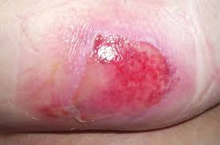  WT03_wound.jpeg | T.I.M.E. Wound Profile  T (Tissue): ~75% Granulation, ~25% NV (slough+necrosis)  I (Infection): Locally infected  M (Moisture): Low to moderate exudate  E (Edge): Non-advancing  Linked test cases: cat_a_type3_dry_infected · cat_b_iodine_thyroid · cat_b_diabetic_foot · cat_c_dry_infected_combo · cat_d_notes_diabetic_nonhealing · cat_e_dfu_infected_ewma

Field | Content / Response
AI Vision Caption  (VLLM output  — read only) | TISSUE: Approximately 80% of the wound bed covered with healthy pink granulation tissue; 20% shows pale, edematous tissue at the periphery.  INFECTION: No visible infection signs. [NOTE: T.I.M.E. profile indicates locally infected — image may not visually show all infection signs]  MOISTURE: The wound bed appears moist with a small amount of serous exudate. Periwound skin is intact without maceration.  EDGE: The wound edges exhibit epibole, with rolled tissue overhanging the wound bed. No evidence of epithelialization.  ADDITIONAL: The wound measures approximately 2 cm × 1.5 cm. Depth is shallow. Periwound skin is slightly erythematous.
1. Image Suitability  (Does this image  represent this  wound type?) | ☐ Suitable — image is a reasonable example ☐ Not suitable — image is misleading / incorrect  Comments / Corrections:
2. AI Caption  Accuracy  (Is the VLLM  description  clinically correct?) | ☐ Accurate — VLLM description is clinically sound ☐ Partially accurate — some errors (note below) ☐ Inaccurate — description is misleading  Comments / Corrections:
3. Caption  Corrections  (What did the AI  miss or get wrong?) | e.g. 'Infection signs visible but VLLM missed them' or 'Tissue % estimate is off'
4. Your Clinical  Description  (What do you see  in this image?) | Describe tissue, infection signs, exudate, wound edges — as you would document it clinically
5. Primary Dressing  Recommendation  (Based on image +  wound type) | e.g. 'Silver dressing, change every 2–3 days' or 'Hydrogel + secondary foam'
6. Secondary  Dressing  (If applicable) | e.g. 'Foam as secondary' or 'Not required'
7. Debridement  Required? | ☐ Not required ☐ Autolytic (dressing-based) ☐ Bedside deslough ☐ Surgical / OT debridement  Comments / Corrections:
8. Antibiotic  Recommendation | ☐ Antibiotic NOT indicated ☐ Topical antimicrobial dressing only (no systemic ABx) ☐ Systemic antibiotic recommended  Comments / Corrections:
9. Referral /  Escalation | ☐ No referral — manageable in community ☐ Referral recommended to GP / clinic ☐ Urgent specialist referral required  Comments / Corrections:
10. Additional  Clinical Notes  (Anything else?) | Any safety concerns, contraindications, Malaysian-specific considerations, etc.
VerdaSense  System Output  (for comparison  — read only) | Recommendation: Primary: Silver dressing (Alt: Hydrogel with secondary dressing) — change every 2–3 days  Contraindicated: None specified by algorithm
Prior Panel  Comments  (from Cat A  review — read only) | Panel 1: Debridement of edges/slough with daily hydrogel; if 2–3 days, preferably hydrofibre + ABx  Panel 2: Modern dressing and assess wound progression  Panel 3: Agreed + wound debridement of the slough

WT04 — Type 4 — Locally Infected, High Exudate
⚠ Antibiotic consideration required
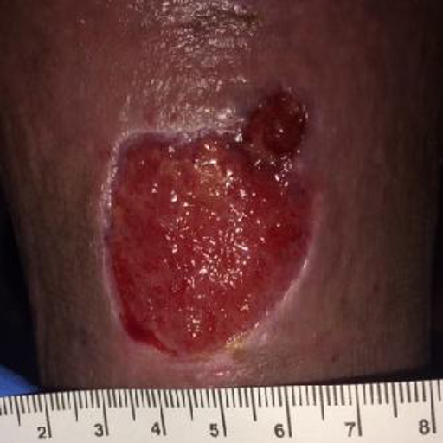  WT04_wsnet_0816.png | T.I.M.E. Wound Profile  T (Tissue): ~80% Granulation, 12–20% NV (slough)  I (Infection): Locally infected  M (Moisture): High exudate  E (Edge): Non-advancing  Linked test cases: cat_a_type4_wet_infected · cat_d_notes_infection_override

Field | Content / Response
AI Vision Caption  (VLLM output  — read only) | TISSUE: Approximately 85% healthy red granulation tissue, 15% pale yellow fibrinous slough along the edges. No necrotic tissue observed.  INFECTION: No visible infection signs. [NOTE: T.I.M.E. profile indicates locally infected]  MOISTURE: The wound bed appears moist with a thin layer of serous exudate. Periwound skin shows no maceration.  EDGE: Wound edges exhibit slight epibole, appearing rolled. Edges are undermined slightly.  ADDITIONAL: The wound measures approximately 4 cm × 3 cm. Depth appears shallow, less than 0.5 cm. Periwound skin intact but mildly erythematous.
1. Image Suitability  (Does this image  represent this  wound type?) | ☐ Suitable — image is a reasonable example ☐ Not suitable — image is misleading / incorrect  Comments / Corrections:
2. AI Caption  Accuracy  (Is the VLLM  description  clinically correct?) | ☐ Accurate — VLLM description is clinically sound ☐ Partially accurate — some errors (note below) ☐ Inaccurate — description is misleading  Comments / Corrections:
3. Caption  Corrections  (What did the AI  miss or get wrong?) | e.g. 'Infection signs visible but VLLM missed them' or 'Tissue % estimate is off'
4. Your Clinical  Description  (What do you see  in this image?) | Describe tissue, infection signs, exudate, wound edges — as you would document it clinically
5. Primary Dressing  Recommendation  (Based on image +  wound type) | e.g. 'Silver dressing, change every 2–3 days' or 'Hydrogel + secondary foam'
6. Secondary  Dressing  (If applicable) | e.g. 'Foam as secondary' or 'Not required'
7. Debridement  Required? | ☐ Not required ☐ Autolytic (dressing-based) ☐ Bedside deslough ☐ Surgical / OT debridement  Comments / Corrections:
8. Antibiotic  Recommendation | ☐ Antibiotic NOT indicated ☐ Topical antimicrobial dressing only (no systemic ABx) ☐ Systemic antibiotic recommended  Comments / Corrections:
9. Referral /  Escalation | ☐ No referral — manageable in community ☐ Referral recommended to GP / clinic ☐ Urgent specialist referral required  Comments / Corrections:
10. Additional  Clinical Notes  (Anything else?) | Any safety concerns, contraindications, Malaysian-specific considerations, etc.
VerdaSense  System Output  (for comparison  — read only) | Recommendation: Primary: Silver dressing + Alginate (Alt: Silver + Hydrofibre) — change every 2–3 days; secondary dressing required  Contraindicated: None specified by algorithm
Prior Panel  Comments  (from Cat A  review — read only) | Panel 1: Debridement with the dressing + ABx  Panel 2: Suggest daily dressing instead of modern dressing as high exudate +/- bedside deslough first  Panel 3: Agreed + wound debridement of the slough

WT05 — Type 5 — Necrotic/Sloughy, Dry, Not Infected
✓ No antibiotic · No referral required
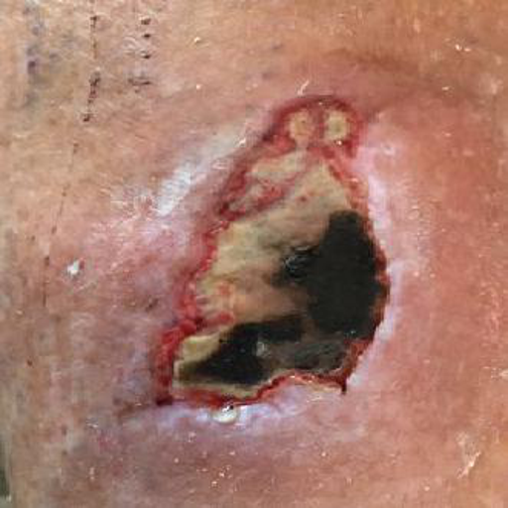  WT05_wsnet_0384.png | T.I.M.E. Wound Profile  T (Tissue): 40–50% Necrotic/Slough, ~30% Granulation  I (Infection): Not infected  M (Moisture): Low/dry exudate  E (Edge): Non-advancing  Linked test cases: cat_a_type5_dry_necrotic · cat_b_alginate_dry_wound · cat_b_honey_dry_necrotic

Field | Content / Response
AI Vision Caption  (VLLM output  — read only) | TISSUE: Approximately 50% healthy red granulation tissue, 30% yellow fibrinous slough, 20% dark necrotic eschar at the base.  INFECTION: No visible infection signs.  MOISTURE: The wound bed appears moist without excessive exudate. Periwound skin is intact but slightly erythematous.  EDGE: Wound edges show rolled epibole with some undermining noted. Epithelialization is minimal, edges appear non-advancing.  ADDITIONAL: Estimated wound size approximately 2 cm × 2 cm. Depth varies with some areas of deeper tissue loss. Periwound skin shows mild erythema.
1. Image Suitability  (Does this image  represent this  wound type?) | ☐ Suitable — image is a reasonable example ☐ Not suitable — image is misleading / incorrect  Comments / Corrections:
2. AI Caption  Accuracy  (Is the VLLM  description  clinically correct?) | ☐ Accurate — VLLM description is clinically sound ☐ Partially accurate — some errors (note below) ☐ Inaccurate — description is misleading  Comments / Corrections:
3. Caption  Corrections  (What did the AI  miss or get wrong?) | e.g. 'Infection signs visible but VLLM missed them' or 'Tissue % estimate is off'
4. Your Clinical  Description  (What do you see  in this image?) | Describe tissue, infection signs, exudate, wound edges — as you would document it clinically
5. Primary Dressing  Recommendation  (Based on image +  wound type) | e.g. 'Silver dressing, change every 2–3 days' or 'Hydrogel + secondary foam'
6. Secondary  Dressing  (If applicable) | e.g. 'Foam as secondary' or 'Not required'
7. Debridement  Required? | ☐ Not required ☐ Autolytic (dressing-based) ☐ Bedside deslough ☐ Surgical / OT debridement  Comments / Corrections:
8. Antibiotic  Recommendation | ☐ Antibiotic NOT indicated ☐ Topical antimicrobial dressing only (no systemic ABx) ☐ Systemic antibiotic recommended  Comments / Corrections:
9. Referral /  Escalation | ☐ No referral — manageable in community ☐ Referral recommended to GP / clinic ☐ Urgent specialist referral required  Comments / Corrections:
10. Additional  Clinical Notes  (Anything else?) | Any safety concerns, contraindications, Malaysian-specific considerations, etc.
VerdaSense  System Output  (for comparison  — read only) | Recommendation: Primary: Hydrogel (no direct alternative) — change every 2–3 days; secondary dressing required  Contraindicated: Alginate · Hydrofibre (not suitable for dry wounds)
Prior Panel  Comments  (from Cat A  review — read only) | Panel 1: Debridement and daily hydrogel; need expert opinion and assess vascular supply (sometimes associated arterial compromise)  Panel 2: Chemical debridement then bedside deslough  Panel 3: Agreed

WT06 — Type 6 — Necrotic/Sloughy, High Exudate, Not Infected
⬆ Specialist referral indicated
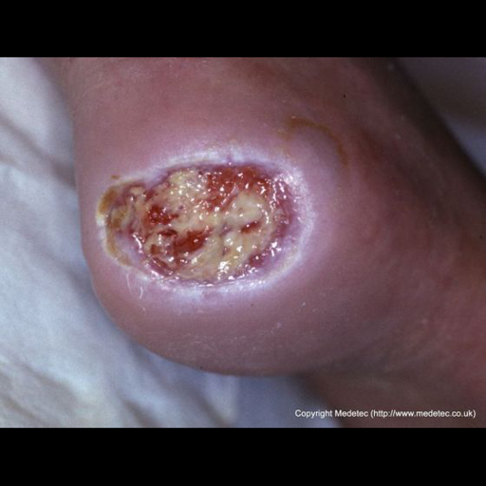  WT06_medetec_0298.png | T.I.M.E. Wound Profile  T (Tissue): 30–35% Necrotic, 30–35% Slough, ~35% Granulation  I (Infection): Not infected  M (Moisture): High exudate  E (Edge): Non-advancing  Linked test cases: cat_a_type6_wet_necrotic · cat_b_referral_type6 · cat_d_notes_npwt_adjunct · cat_e_vlu_chronic_ewma

Field | Content / Response
AI Vision Caption  (VLLM output  — read only) | TISSUE: Approximately 50% healthy red granulation tissue, 40% pale yellow fibrinous slough, 10% dark necrotic eschar at the base.  INFECTION: No visible infection signs.  MOISTURE: Moderate exudate; wound bed appears moist. Periwound skin is slightly macerated due to moisture exposure.  EDGE: Wound edges show epibole with rolled appearance, undermining noted along lateral aspect. Epithelialization is minimal.  ADDITIONAL: Estimated wound size approximately 2 cm × 3 cm. Periwound skin exhibits mild erythema, possibly due to moisture.
1. Image Suitability  (Does this image  represent this  wound type?) | ☐ Suitable — image is a reasonable example ☐ Not suitable — image is misleading / incorrect  Comments / Corrections:
2. AI Caption  Accuracy  (Is the VLLM  description  clinically correct?) | ☐ Accurate — VLLM description is clinically sound ☐ Partially accurate — some errors (note below) ☐ Inaccurate — description is misleading  Comments / Corrections:
3. Caption  Corrections  (What did the AI  miss or get wrong?) | e.g. 'Infection signs visible but VLLM missed them' or 'Tissue % estimate is off'
4. Your Clinical  Description  (What do you see  in this image?) | Describe tissue, infection signs, exudate, wound edges — as you would document it clinically
5. Primary Dressing  Recommendation  (Based on image +  wound type) | e.g. 'Silver dressing, change every 2–3 days' or 'Hydrogel + secondary foam'
6. Secondary  Dressing  (If applicable) | e.g. 'Foam as secondary' or 'Not required'
7. Debridement  Required? | ☐ Not required ☐ Autolytic (dressing-based) ☐ Bedside deslough ☐ Surgical / OT debridement  Comments / Corrections:
8. Antibiotic  Recommendation | ☐ Antibiotic NOT indicated ☐ Topical antimicrobial dressing only (no systemic ABx) ☐ Systemic antibiotic recommended  Comments / Corrections:
9. Referral /  Escalation | ☐ No referral — manageable in community ☐ Referral recommended to GP / clinic ☐ Urgent specialist referral required  Comments / Corrections:
10. Additional  Clinical Notes  (Anything else?) | Any safety concerns, contraindications, Malaysian-specific considerations, etc.
VerdaSense  System Output  (for comparison  — read only) | Recommendation: Primary: Alginate (sheet/rope) (Alt: Hydrofibre) — change every 2–5 days; referral to specialist indicated  Contraindicated: None specified by algorithm
Prior Panel  Comments  (from Cat A  review — read only) | Panel 1: Debridement with daily or bd Dermasyn dressing for 1–2 days; when debridement assessment no longer required, change to Ag Alginate  Panel 2: Daily dressing + deslough  Panel 3: Agreed + wound debridement of the slough

WT07 — Type 7 — Infected + Necrotic, Low Exudate (Complex)
⚠ Antibiotic consideration required ⬆ Specialist referral indicated
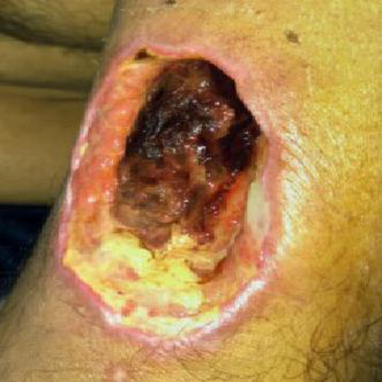  WT07_wsnet_0539.png | T.I.M.E. Wound Profile  T (Tissue): 25–40% Necrotic, 25–30% Slough, ~20% Granulation  I (Infection): Locally infected  M (Moisture): Low to moderate exudate  E (Edge): Non-advancing  Linked test cases: cat_a_type7_dry_infected_necrotic · cat_c_time_assessment_mixed

Field | Content / Response
AI Vision Caption  (VLLM output  — read only) | TISSUE: Approximately 50% dark necrotic eschar centrally, 30% yellow fibrinous slough along edges, 20% granulation tissue visible beneath slough.  INFECTION: Visible infection indicators — perilesional erythema, localised warmth, and purulent exudate suggest active infection.  MOISTURE: Moderate exudate level; wound bed appears moist with visible cloudy discharge. Periwound skin shows early signs of maceration.  EDGE: Wound edges exhibit epibole with rolled appearance, undermining noted at lower margin. Epithelialization is absent; edges appear non-advancing.  ADDITIONAL: Estimated wound size approximately 5 cm × 4 cm. Periwound skin displays mild erythema and oedema.
1. Image Suitability  (Does this image  represent this  wound type?) | ☐ Suitable — image is a reasonable example ☐ Not suitable — image is misleading / incorrect  Comments / Corrections:
2. AI Caption  Accuracy  (Is the VLLM  description  clinically correct?) | ☐ Accurate — VLLM description is clinically sound ☐ Partially accurate — some errors (note below) ☐ Inaccurate — description is misleading  Comments / Corrections:
3. Caption  Corrections  (What did the AI  miss or get wrong?) | e.g. 'Infection signs visible but VLLM missed them' or 'Tissue % estimate is off'
4. Your Clinical  Description  (What do you see  in this image?) | Describe tissue, infection signs, exudate, wound edges — as you would document it clinically
5. Primary Dressing  Recommendation  (Based on image +  wound type) | e.g. 'Silver dressing, change every 2–3 days' or 'Hydrogel + secondary foam'
6. Secondary  Dressing  (If applicable) | e.g. 'Foam as secondary' or 'Not required'
7. Debridement  Required? | ☐ Not required ☐ Autolytic (dressing-based) ☐ Bedside deslough ☐ Surgical / OT debridement  Comments / Corrections:
8. Antibiotic  Recommendation | ☐ Antibiotic NOT indicated ☐ Topical antimicrobial dressing only (no systemic ABx) ☐ Systemic antibiotic recommended  Comments / Corrections:
9. Referral /  Escalation | ☐ No referral — manageable in community ☐ Referral recommended to GP / clinic ☐ Urgent specialist referral required  Comments / Corrections:
10. Additional  Clinical Notes  (Anything else?) | Any safety concerns, contraindications, Malaysian-specific considerations, etc.
VerdaSense  System Output  (for comparison  — read only) | Recommendation: Primary: Silver dressing + Hydrogel (hydrogel for autolytic debridement, silver for infection) — change every 2–3 days; specialist referral required  Contraindicated: Alginate · Hydrofibre (not suitable for dry/infected necrotic wounds)
Prior Panel  Comments  (from Cat A  review — read only) | Panel 1: Debridement with daily or bd Dermasyn dressing until debridement no longer required, then change to Ag Alginate + ABx  Panel 2: Daily dressing + deslough + antibiotic; might need OT debridement  Panel 3: Wound debridement then dressing + antibiotic

WT08 — Type 8 — Infected + Necrotic, High Exudate (Most Complex)
⚠ Antibiotic consideration required ⬆ Specialist referral indicated
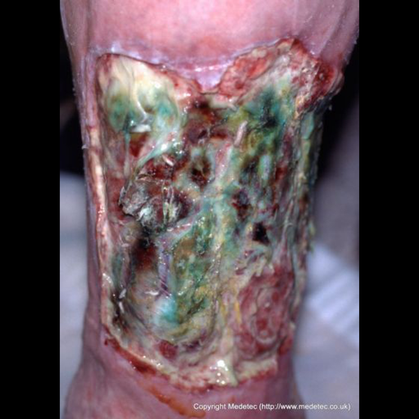  WT08_medetec_0175.png | T.I.M.E. Wound Profile  T (Tissue): 30–50% Necrotic, 20–35% Slough, ~35% Granulation  I (Infection): Locally infected  M (Moisture): High exudate  E (Edge): Non-advancing  Linked test cases: cat_a_type8_wet_infected_necrotic · cat_b_npwt_necrotic_eschar · cat_c_malodour_type8

Field | Content / Response
AI Vision Caption  (VLLM output  — read only) | TISSUE: Approximately 40% healthy red granulation tissue, 50% greenish-yellow slough covering the wound bed, and 10% dark necrotic tissue at the base.  INFECTION: Visible infection indicators — green/cloudy discharge, perilesional erythema, and possible purulent exudate.  MOISTURE: The wound bed is moist with visible exudate that appears cloudy and purulent. Periwound skin shows signs of maceration.  EDGE: The wound edges exhibit epibole with some undermining noted. Edges appear rolled and non-advancing, lacking epithelialization.  ADDITIONAL: The wound measures approximately 5 cm × 3 cm with depth suggesting involvement beyond superficial layers. Periwound skin is erythematous and macerated.
1. Image Suitability  (Does this image  represent this  wound type?) | ☐ Suitable — image is a reasonable example ☐ Not suitable — image is misleading / incorrect  Comments / Corrections:
2. AI Caption  Accuracy  (Is the VLLM  description  clinically correct?) | ☐ Accurate — VLLM description is clinically sound ☐ Partially accurate — some errors (note below) ☐ Inaccurate — description is misleading  Comments / Corrections:
3. Caption  Corrections  (What did the AI  miss or get wrong?) | e.g. 'Infection signs visible but VLLM missed them' or 'Tissue % estimate is off'
4. Your Clinical  Description  (What do you see  in this image?) | Describe tissue, infection signs, exudate, wound edges — as you would document it clinically
5. Primary Dressing  Recommendation  (Based on image +  wound type) | e.g. 'Silver dressing, change every 2–3 days' or 'Hydrogel + secondary foam'
6. Secondary  Dressing  (If applicable) | e.g. 'Foam as secondary' or 'Not required'
7. Debridement  Required? | ☐ Not required ☐ Autolytic (dressing-based) ☐ Bedside deslough ☐ Surgical / OT debridement  Comments / Corrections:
8. Antibiotic  Recommendation | ☐ Antibiotic NOT indicated ☐ Topical antimicrobial dressing only (no systemic ABx) ☐ Systemic antibiotic recommended  Comments / Corrections:
9. Referral /  Escalation | ☐ No referral — manageable in community ☐ Referral recommended to GP / clinic ☐ Urgent specialist referral required  Comments / Corrections:
10. Additional  Clinical Notes  (Anything else?) | Any safety concerns, contraindications, Malaysian-specific considerations, etc.
VerdaSense  System Output  (for comparison  — read only) | Recommendation: Primary: Silver dressing + Alginate (Alt: Silver + Hydrofibre; charcoal if malodour) — change every 2–3 days; urgent specialist referral  Contraindicated: None specified by algorithm
Prior Panel  Comments  (from Cat A  review — read only) | Panel 1: Debridement with daily or bd Dermasyn dressing until debridement no longer required, then change to Ag Alginate + ABx  Panel 2: Daily dressing + deslough + antibiotic; might need OT debridement  Panel 3: Wound debridement then dressing + antibiotic

Overall Comments & Summary
Question | Your Response
Images accepted  (WT numbers) | Which of the 8 images are suitable? List WT numbers: _______________________
Images rejected  (WT numbers + reason) | Which images need replacing and why?
Missing wound  types / scenarios | Are there wound types important for Malaysian patients NOT covered by WT01–WT08?
VLLM caption  overall quality | Overall, how well does the AI vision model describe wound characteristics?  ☐ Good — clinically useful descriptions  ☐ Partial — some useful, some inaccurate  ☐ Poor — descriptions cannot be trusted clinically
Recommended  changes to  VerdaSense system | What is the most important clinical improvement you would suggest for FYP2?
Availability of  clinical images  (optional) | Do you have access to de-identified wound photographs from clinical practice?  ☐ Yes — I can share (please advise on ethics/consent process)  ☐ No — public datasets are sufficient for this research purpose
Willingness to  conduct final  human evaluation  (15–20 min, online) | At project completion, would you be willing to rate 8–10 AI recommendations  on clinical accuracy (Likert 1–5 scale)?  ☐ Yes ☐ No ☐ Maybe — contact me closer to date

Thank you for your time, Ms Saw. Your clinical expertise directly improves the accuracy and safety of VerdaSense. Please return this form via WhatsApp or email to Tee Qi Jing (23004894).

Prepared by Tee Qi Jing (23004894) · VerdaSense FYP2 · Universiti Malaya · June 2026

